VARIANCE INFLATION FACTOR

**How variance inflation factor works**

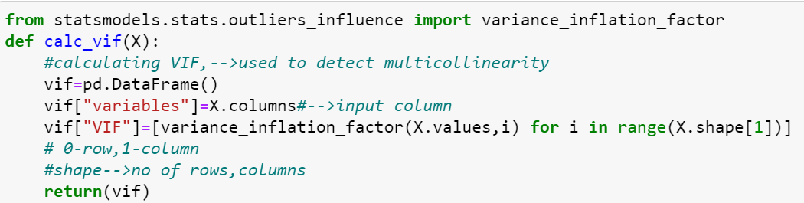

VIF is used to detect multicollinearity in a model ,i.e.,which is highly linearly related to each other.

**How each part of code works:**

**from statsmodels.stats.outliers_influence import variance_inflation_factor:**

This imports the variance_inflation_factor(VIF) function from the statsmodels.stats.outliers_influence module. This function is used to calculate the VIF.

**def calc_vif(X):**

This defines a function named calc_vif that takes a DataFrame X as input.

**vif=pd.DataFrame():** This initializes an empty DataFrame called vif which will store the variable names and their corresponding VIF values.

**vif["variables"]=X.columns:** This creates a column named "variables" in the vif DataFrame and assigns it the column names of the input DataFrame X.

**vif["VIF"]=[variance_inflation_factor(X.values,i) for i in range(X.shape[1])]:**

This calculates the VIF for each variable in X using a list comprehension. For each column index i (ranging from 0 to the number of columns in X - 1), it computes the VIF using the variance_inflation_factor function and assigns the result to the corresponding row in the "VIF" column of the vif DataFrame.

**return(vif):** This returns the vif DataFrame containing the variable names and their corresponding VIF values.

Overall, this function provides a convenient way to calculate VIF for all variables in a DataFrame, which can be useful for identifying multicollinearity issues